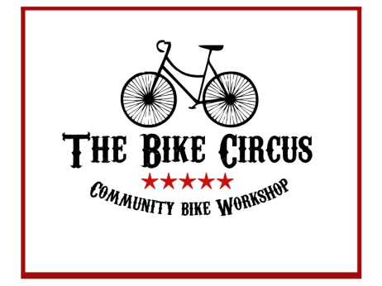

Run Away With the Circus

The Clonakilty Bike Circus has openings for bike enthusiasts to become apprentice bike mechanics. The training covers all aspects of basic bicycle maintenance and repair, including:

Bicycle nomenclature
Shop safety & etiquette
Use of primary bicycle tools & tool care
How to ‘M Check’ a bicycle
Puncture repair & tyre mounting
Bicycle cleaning & lubrication
Brake maintenance & repair
Derailleur maintenance & repair
Chain cleaning, testing, removal & replacement
Bicycle wheel construction & repair
Bearing cleaning & replacement
Introduction to E-bikes

There is no tuition charge, however each student must complete all the instructional segments, fulfil 100 hours of hands-on bike repair, and completely take down and assemble a bicycle.
The Clonakilty Bike Circus is a membership public workshop responsible for maintaining the rental fleet of the Clon Bike Hire Scheme. Jack, its chief mechanic has more than fifty years’ experience working on bikes. He is assisted by Jane and Graeme, also experienced bicycle mechanics.
During their free time students are invited to work on their own bikes or, if they like, enter the Bike Circus’ VolksBike Contest with a potential of winning €500 at the 2020 Clonakilty Bicycle Festival. (Details available on request.)
Apprenticeships are open to anyone sixteen years of age or older. Under sixteens will be considered if sincere and responsible. For further information, contact Jack at cisco_moran@yahoo.com.

