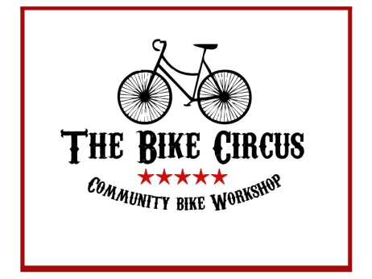

VolksBike Challenge
€500 Grand Prize

The Concept: The world needs a reliable, durable, easily serviced and repaired, everyday bike, a bike for all seasons.

The Challenge: Can you build this bike from readily available components, preferably salvaged from skips, cardboard boxes under your bed, and recycling yards?

Suggestions: The VolksBike is meant to be comfortable, safe, and utilitarian. A step-thru frame and secure rear rack are probably essential. Drive-train simplicity is critical. Be prepared to defend the choice you make here – single speed, rear derailleur, or internal gear hub? Twist, thumb, or friction shifters? Can your bike be serviced by the side of the road in the pouring rain with a handful of everyday tools?
Are the components serviceable? For instance, are the pedals ‘use and lose’ or capable of lasting a lifetime with periodic service?
Ebike adaptable? The VolksBike is a pack mule and daily commuter’s bike. It should be readily adaptable to one of the many conversion kits now available.
Elegance and appeal are important. Paint your bike, polish its bright work, and install a fancy ding-bell. Add a flower holder, not a basket, on the front bars.
Recommended reading, How to Build a Bike, by Jenni Gwiazdowski, available at Amazon and elsewhere. Take a look at Paul Components website for inspiration, paulcomp.com. Further information contact Jack Kelleher, cisco_moran@yahoo.com.

Name That Bike Contest
€100 Prize

We’ve called our project bike the ‘VolksBike’ to help entrants visualize what we want, the classic VW Beatle of the bicycle world. However, we hope this contest will continue annually. With all respect to the clever engineers who gave us the fun little car, we want a name for our target bike which honours West Cork, Ireland, and the Clonakilty Bike Circus, our organization. We are an all-volunteer, non-profit, group which has flourished in the welcoming community here. We want to say thanks by the name given to this dream bike.

If you’re good with words, send us your suggestion. If we adopt it, we’ll send you €100. Entrants must be submitted by December 31, 2019 so we can use your name in our promotional literature. Submit your suggestion to Jack, cisco_moran@yahoo.com. You may enter this contest as often as you like.

Terms & Conditions: Both contests are open to individuals and groups everywhere. We welcome school project bikes or those assembled as a club activity. However, VolksBike entrants must present their bicycle at the 2020 Clonakilty Bike Festival in June and ride their bike in at least one open road event. VolksBike finalists will be selected by a panel of judges during the Festival.
The VolksBike prize winner will be chosen from among the finalists by secret ballot from the Bike Festival Participants after presentation and discussion at a Festival Forum. Each entrant must be prepared to give a five-minute presentation of their bike. The winner will receive a grand prize of €500, two runners-up will each receive a prize of €100 each.
Name That Bike entries will be selected by a local panel and announced in January 2020.

